32.54: For the electron in the classical hydrogen atom, its acceleration is:
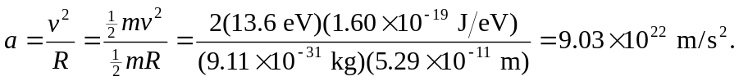
Then using the formula for the rate of energy emission given in Pr. (33-49):
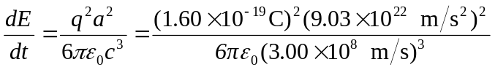
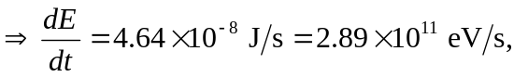 which means that the electron would almost immediately lose all its energy!

